**Supermarket Data Warehouse project**



**Project Submitted to:**Digital Egypt Pioneers Initiative

**Supermarket Data Warehouse project**

Superviser :

**Eng.Eslam hussein**

Presented by:

**Youssef Azam Mahfouz Hossam Ahmed Ali**

**Menna Mostafa Salah Mostafa Gamal Arafa**

**Maryam Omer Ahmed**

### **2. Table of Contents**

* Introduction
* Project Goals
* Entity-Relationship Diagram (ERD)
* Schema and Database Creation
* Gathering Business Information
* Data Modeling and Data Warehouse Design
* ETL Process (SSIS)
* Reporting (Power BI)
* Data Analysis (Python)
* Machine Learning (Regression Model)
* Cloud Implementation (Azurer)
* Project Timeline
* Conclusion

**3. Introduction**

#### 

In today's competitive retail environment, supermarkets face increasing challenges in managing massive volumes of data generated daily from various operations. Efficient data management is key to sustaining growth, ensuring profitability, and maintaining a competitive edge. The **Supermarket Data Warehouse Project** aims to address these challenges by designing and implementing a comprehensive data management system that will streamline and enhance various supermarket operations, from sales tracking to inventory control, and customer relationship management.

The goal of this project is to build an end-to-end data warehouse solution that consolidates all critical supermarket data into a single repository. By integrating disparate data sources, the system will provide actionable insights to improve decision-making and operational efficiency.

At its core, the project involves:

1. **Designing a Data Warehouse:** The project employs a robust data warehouse architecture to ensure scalability and performance. This includes the creation of fact and dimension tables to support advanced analytics.
2. **Implementing an ETL Process:** A seamless Extract, Transform, Load (ETL) pipeline is developed using SQL Server Integration Services (SSIS) to transform raw data into structured formats that are ready for analysis.
3. **Enabling Business Intelligence with Power BI:** With Power BI, dynamic reports and dashboards are created, allowing supermarket managers and stakeholders to visualize real-time data, track key performance indicators (KPIs), and make informed decisions.
4. **Advanced Data Analysis & Machine Learning:** Python is leveraged to carry out advanced data analytics, such as predicting future trends using machine learning models. This includes building regression models to forecast supermarket profits and identify key factors driving sales.

The project covers every phase of the data lifecycle, from data extraction to insightful reporting, offering a 360-degree view of the supermarket's operations. By unifying transactional and analytical processes, the system provides a holistic understanding of sales trends, customer behavior, and inventory performance.

### **Key Features of the Project:**

* **Centralized Data Management:** By consolidating various data sources into one structured warehouse, the project eliminates data silos, ensuring that all departments have access to consistent and reliable information.
* **Improved Decision Making:** With detailed data modeling and business intelligence tools like Power BI, supermarket management can make quicker, more informed decisions based on real-time data and trends.
* **Efficiency and Scalability:** The system is built using Microsoft SQL Server, a scalable solution capable of handling large volumes of data while ensuring high performance. This allows the system to grow with the business.
* **Data Insights through Analytics:** Leveraging Python for data analysis adds an extra layer of insight, helping uncover hidden patterns and trends that may not be immediately visible in traditional reports.
* **Forecasting with Machine Learning:** Predictive models enable the supermarket to forecast profits, manage inventory effectively, and optimize operations, ensuring that the right products are available to meet customer demand.

In summary, the **Supermarket Data Warehouse Project** not only enhances the efficiency of day-to-day operations but also serves as a powerful tool for long-term strategic planning and growth. The integration of modern data management techniques, advanced analytics, and machine learning models makes this project a critical component for any supermarket looking to stay ahead in a competitive market.

### **4. Project Goals**

#### 

* **Design a comprehensive Entity-Relationship Diagram (ERD)**: Create a detailed ERD that maps all supermarket operations.
* **Convert ERD to Schema**: Implement the ERD into a database schema with tables, keys, and relationships.
* **Create a Data Warehouse**: Develop a data warehouse to support comprehensive reporting and analytics.
* **ETL Process in SSIS**: Design an ETL process using SQL Server Integration Services (SSIS) to ensure data accuracy and consistency in the data warehouse.
* **Develop Power BI Reports**: Create dynamic reports to visualize critical business metrics and KPIs.
* **Data Analysis Using Python**: Conduct deeper data analysis using Python to uncover additional insights and trends.
* **Machine Learning Model**: Implement a regression model to predict supermarket profits based on historical data.

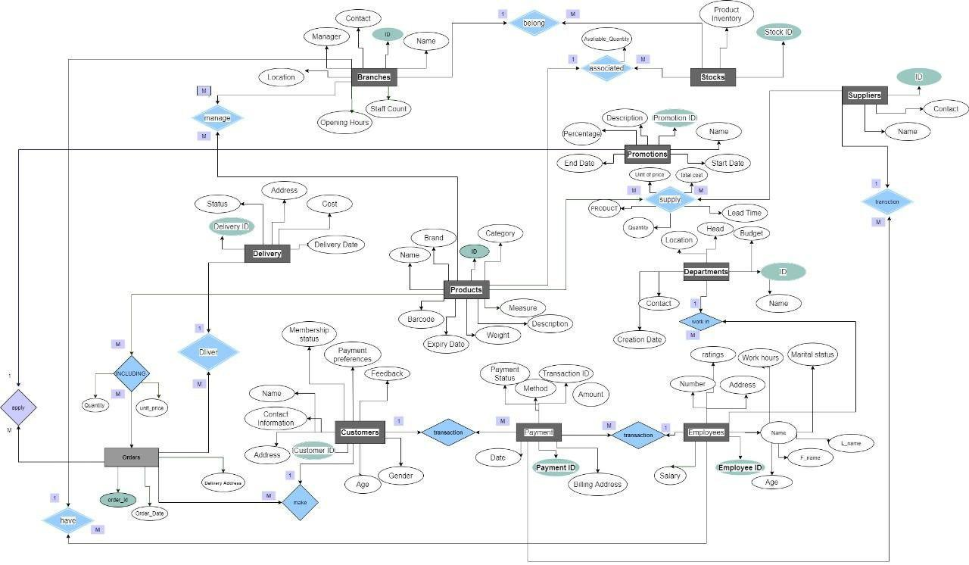

### **5. Entity-Relationship Diagram (ERD)**

The **Entity-Relationship Diagram (ERD)** is a fundamental aspect of database design that visually represents the relationships between various entities within a system. In the context of the **Supermarket Data Warehouse Project**, the ERD serves as the blueprint for the database structure, ensuring that all relevant entities (such as products, customers, sales, and employees) are properly identified and their interconnections are clearly mapped out.

### **Key Elements of the ERD in This Project:**

1. **Entities:**
   * **Products:** Represents all the products sold by the supermarket. Each product entity holds attributes like product name, price, category, and stock levels.
   * **Customers:** Contains information about the supermarket's customers, including their contact details, purchasing behavior, and loyalty status.
   * **Sales:** This entity tracks every transaction made, including details like the product sold, the customer who made the purchase, the date, and the amount.
   * **Employees:** Represents the staff working in the supermarket, storing details such as their roles, departments, and performance data.
   * **Branches:** Captures data on various supermarket branches, including location, size, and performance metrics.
2. **Relationships:**
   * The ERD illustrates how these entities are interconnected. For instance:
     + **Sales** are linked to both **Products** and **Customers** through relationships that specify which products were purchased by which customers.
     + **Employees** are linked to **Sales** data to track which staff members handled specific transactions or managed certain departments.
     + **Branches** are connected to **Sales**, allowing for the comparison of performance metrics across different locations.
3. **Primary Keys and Foreign Keys:**
   * Every entity in the ERD has a **primary key**, which uniquely identifies each record in that entity. For example, each **Product** has a unique product ID, and each **Customer** has a unique customer ID.
   * **Foreign keys** are used to establish relationships between entities. For instance, the **Sales** entity might contain a foreign key for **Product ID** and **Customer ID** to link each sale to the specific product and customer involved in the transaction.
4. **Normalization and Data Integrity:**
   * The ERD ensures that the database adheres to normalization principles, which prevent data redundancy and maintain data integrity. Each entity is designed to store data efficiently, ensuring that information is only stored once in the appropriate table.
   * **Referential integrity** is maintained through the relationships between entities, ensuring that all sales, for example, are linked to valid products, customers, and employees.

### **Importance of ERD in the Project:**

* **Clear Structure:** The ERD provides a clear visual representation of the database structure, making it easier for stakeholders

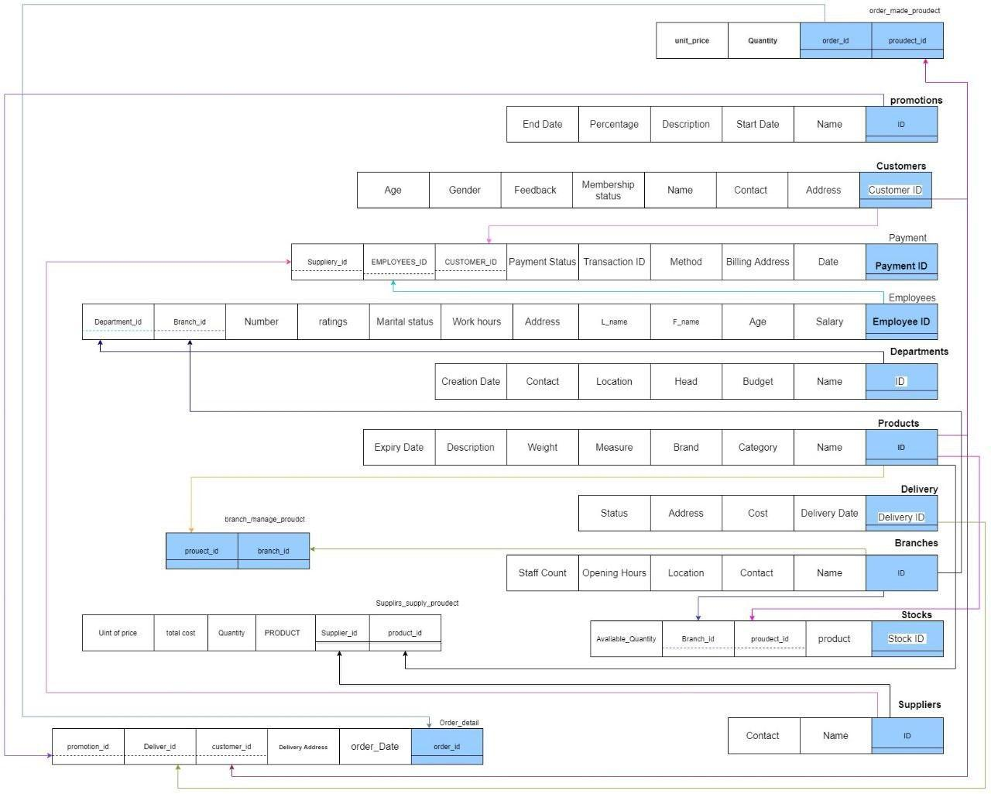

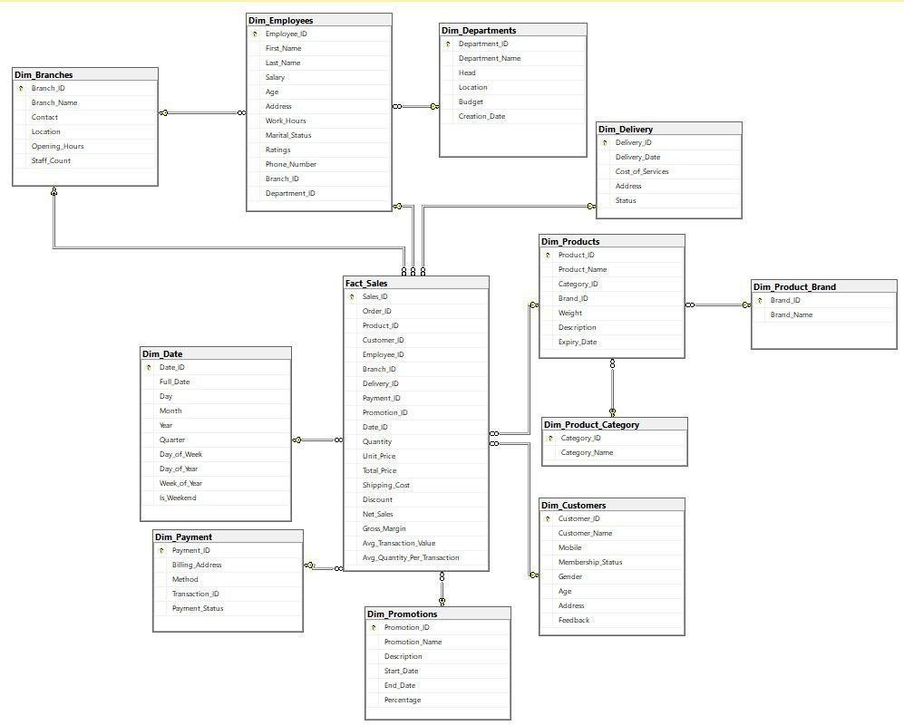

### **6. Database Creation (Schema and Tables)**

The **Database Creation** phase is a critical step in translating the conceptual design of the system, as defined in the Entity-Relationship Diagram (ERD), into an actual working database. The database schema acts as the blueprint for how the data is organized and structured, ensuring that it supports the supermarket’s business processes effectively and efficiently. This phase involves defining the structure, constraints, and relationships within the database, followed by the actual creation of tables in Microsoft SQL Server (MSSQL).

### **Schema Design:**

The **schema** represents the logical structure of the database, detailing how data is organized into tables, relationships, keys, and constraints. The design is based on the previously developed ERD and ensures that the database is optimized for performance, scalability, and maintainability.

1. **Tables**: Each entity from the ERD, such as **Products**, **Customers**, **Sales**, **Employees**, and **Branches**, is mapped to a specific table in the database. Each table contains a set of **columns** that represent the attributes of that entity. For example, the **Products** table will have columns such as:
   * **ProductID** (Primary Key)
   * **ProductName**
   * **Category**
   * **Price**
   * **StockLevel**
2. **Primary Keys**: Each table is designed with a **primary key** to uniquely identify each record. For instance, the **CustomerID** in the **Customers** table acts as a primary key, ensuring that each customer has a unique identifier. This allows for efficient querying and data retrieval.
3. **Foreign Keys**: To establish relationships between different tables, **foreign keys** are used. For example, the **Sales** table will have a foreign key linking to the **ProductID** in the **Products** table and **CustomerID** in the **Customers** table. This ensures data integrity by enforcing that any sale must refer to valid entries in both the **Products** and **Customers** tables.
4. **Constraints**: Constraints such as **NOT NULL**, **UNIQUE**, and **CHECK** are applied to the schema to ensure data accuracy and consistency. For example:
   * **NOT NULL** on essential fields like **Price** in the **Products** table ensures that no product can be added without a valid price.
   * **CHECK** constraints can enforce that a value, such as **StockLevel**, must be non-negative.
5. **Indexes**: To enhance query performance, **indexes** are created on frequently queried columns, such as **ProductID** and **CustomerID**. This ensures that searches and retrievals based on these fields are optimized for speed.

### **Normalization:**

The schema is designed following **normalization principles** to avoid data redundancy and ensure that each piece of data is stored only once. For example, product information is stored in the **Products** table and not repeated in the **Sales** table. This separation ensures efficient data management and minimizes storage overhead.

### **Ensuring Scalability and Performance:**

The schema is built with scalability in mind, allowing the supermarket to handle growing data volumes as the business expands. Indexing, partitioning, and proper use of relationships ensure that the database performs well under heavy load and continues to support real-time operations like sales transactions and inventory updates.

### **Data Integrity and Consistency:**

Through the use of foreign keys, constraints, and triggers, the database ensures that all entries are valid and that relationships between entities remain consistent. For example, a sale cannot be recorded unless the **ProductID** and **CustomerID** exist in their respective tables, thereby preventing orphaned records or data inconsistencies.

### **Handling Transactions:**

In transactional systems like this one, the database is designed to support **ACID (Atomicity, Consistency, Isolation, Durability)** principles, ensuring that all sales, inventory updates, and customer interactions are processed reliably. This guarantees that the database can handle multiple concurrent transactions without compromising data integrity.



### **7. Gathering Business Information**

**athering business information** is a crucial phase in any data-driven project. It involves identifying and collecting the key questions, metrics, and performance indicators that will guide the development of the data warehouse and the analytical tools used to support decision-making. In the context of the **Supermarket Data Warehouse Project**, this step focuses on understanding the supermarket’s operational needs, sales trends, and customer behaviors to ensure the data warehouse can provide actionable insights for business improvement.

### **Purpose:**

The main objective of gathering business information is to define the specific questions the supermarket needs answers to, such as:

* What products are the most profitable?
* How does sales performance vary by branch, department, or time period?
* What are the seasonal trends in customer purchases?
* Which promotional campaigns lead to the highest return on investment (ROI)?

By gathering this information early in the project, the design of the data warehouse and the ETL (Extract, Transform, Load) processes can be tailored to deliver meaningful insights that directly impact the supermarket's strategic decisions.

### **Key Business Questions:**

Some of the critical questions that drive this project include:

1. **Sales Performance**:
   * What is the total sales revenue for each product category?
   * Which branches and departments are the top performers in terms of revenue and profit margins?
2. **Customer Behavior**:
   * What are the purchasing patterns of customers over time?
   * How do customer preferences vary across different regions or demographics?
3. **Inventory Management**:
   * What are the current inventory levels across all branches?
   * How does inventory turnover differ between product categories and locations?
4. **Promotions and Campaigns**:
   * Which promotional offers lead to the highest increase in sales revenue?
   * What is the return on investment (ROI) for each marketing campaign?

### **Gathering Data for Analysis:**

### **1. Total Sales for Each Product Category**

**Business Question:**What are the total sales and quantity sold for each product category?

**SQL Query:**

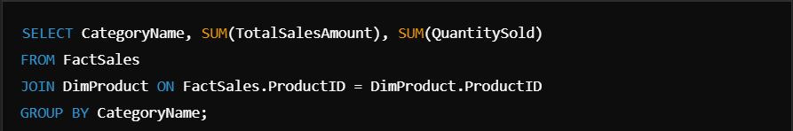

**Purpose:**This query helps the management identify which product categories generate the most revenue, guiding inventory and sales strategies.

### **2. Promotions with Highest Sales Increase**

**Business Question:**Which promotions result in the highest increase in sales?

**SQL Query:**



**Purpose:**The management can evaluate which promotions are the most successful, helping optimize future marketing campaigns.

### **3. Sales Trends Over Time**

**Business Question:**What are the sales trends over time?

**SQL Query:**

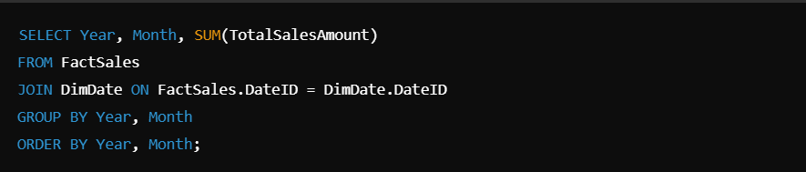

**Purpose:**This helps identify seasonal trends or patterns in sales, enabling better forecasting and planning.

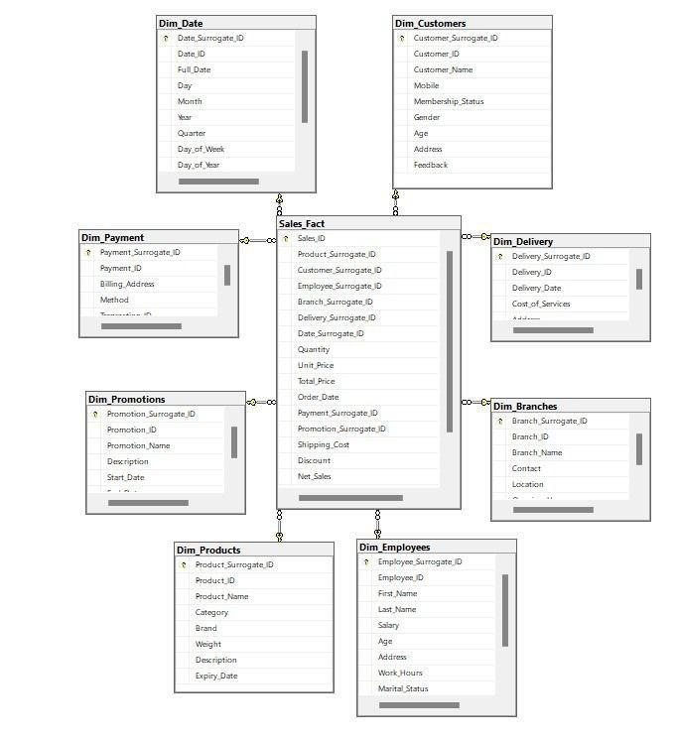

### **8. Data Warehouse Design**

The **Data Warehouse Design** focuses on structuring the data in a way that supports efficient storage, retrieval, and analysis of large volumes of information from various sources. In this project, the data warehouse is designed using the **star schema** model, which consists of:

* **Fact tables** that store quantitative data, such as sales transactions, inventory levels, and profit margins.
* **Dimension tables** that provide descriptive information about entities such as products, customers, branches, and time.

This design enables the supermarket to perform complex queries and generate reports that offer actionable insights, such as identifying top-selling products, analyzing customer behaviors, and monitoring branch performance. The star schema structure allows for faster querying and simplifies data retrieval, making it an ideal choice for business intelligence and reporting purposes.

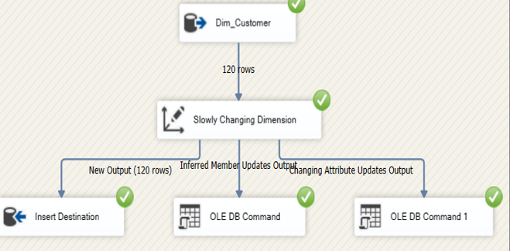 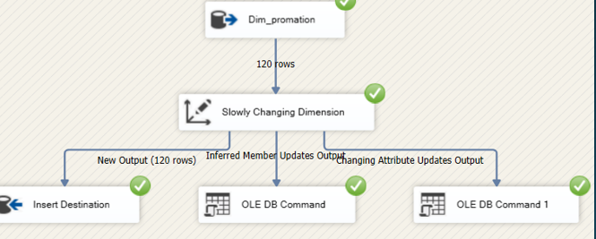

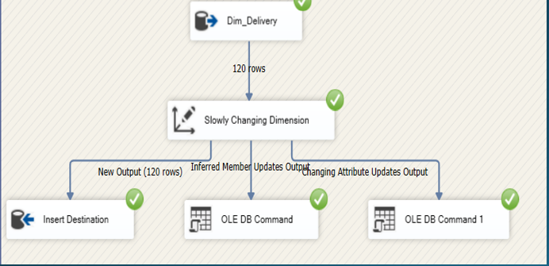

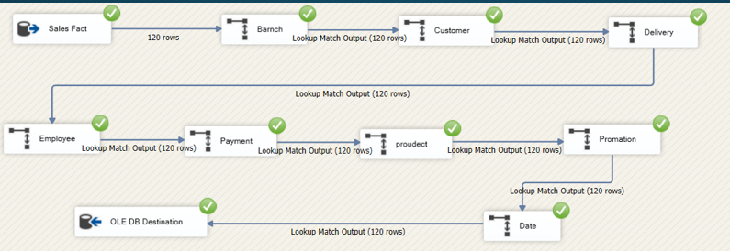

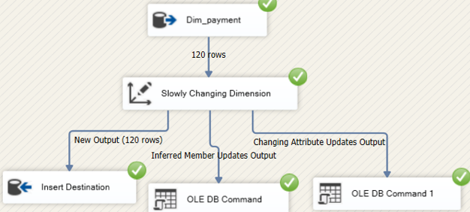

### **9. ETL Process (SSIS)**

The **Extract, Transform, Load (ETL)** process is essential for moving data from various source systems into the data warehouse of the **Supermarket Management System Database Project**. Using **SQL Server Integration Services (SSIS)**, we automate this process to ensure data accuracy and readiness for analysis.

### **1. Extraction (E)**

**Extraction** involves pulling data from multiple sources, including:

* **Point of Sale (POS) systems**: Sales transactions.
* **Inventory systems**: Stock levels and product movements.
* **Customer Relationship Management (CRM) systems**: Customer profiles and purchase history.

In SSIS, data is extracted using tasks like **OLE DB Source** or **Flat File Source**.

**Purpose:**To gather all relevant data for processing without altering the original datasets.

### **2. Transformation (T)**

**Transformation** involves cleaning and restructuring the data to ensure it is accurate and consistent. Key steps include:

* **Data Cleansing**: Removing duplicates and correcting data types.
* **Aggregation**: Summarizing sales data.
* **Data Mapping**: Aligning source fields with the target fields in the data warehouse.

In SSIS, this is accomplished through various transformation tasks, including **Data Conversion**, **Derived Columns**, and handling **Slowly Changing Dimensions** (SCD).

**Purpose:**To ensure that only clean and meaningful data is loaded into the data warehouse.

### **3. Loading (L)**

**Loading** is the final stage, where the transformed data is stored in the data warehouse. This includes populating:

* **Fact Tables**: Such as sales transactions.
* **Dimension Tables**: Such as products and customers.

In SSIS, tasks like **OLE DB Destination** are used to efficiently load the data.

**Purpose:**To make the data available for reporting and analysis.

### **Key Benefits of the ETL Process:**

* **Automation**: Reduces manual effort in data handling.
* **Data Quality**: Ensures only accurate and cleaned data is stored.
* **Performance**: Efficiently handles large volumes of data.

By following this ETL process, the supermarket can maintain a robust data warehouse that supports effective decision-making.

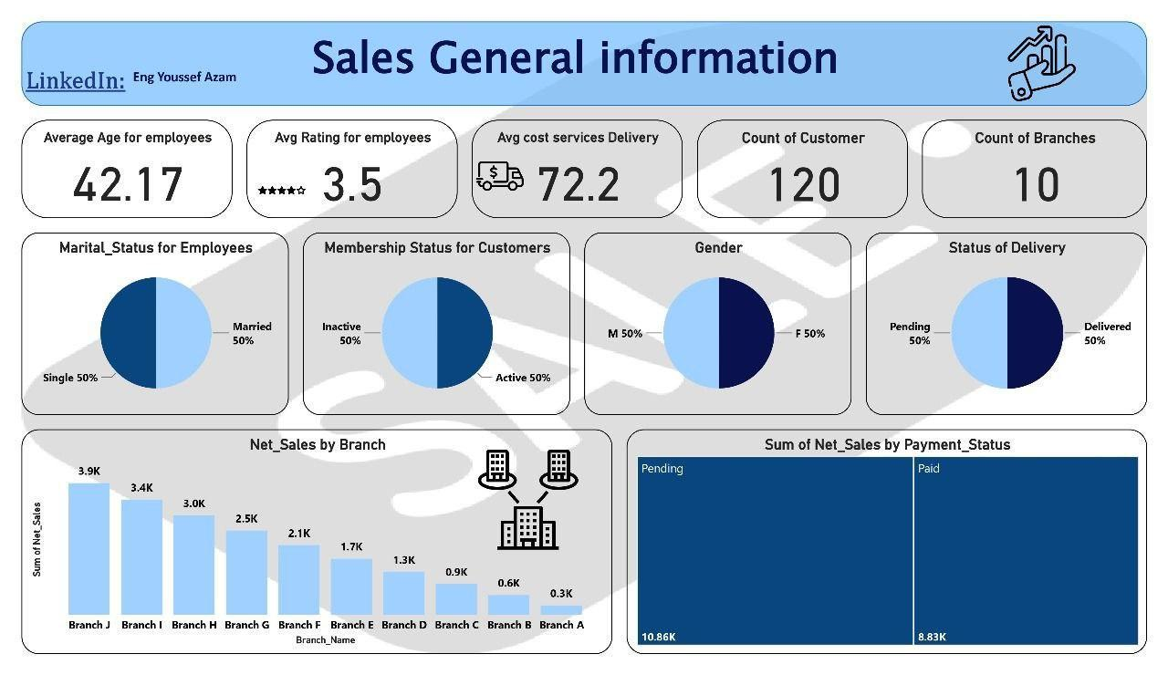

### **10. Reporting in Power BI**

The **Reporting in Power BI** section focuses on transforming raw data from the data warehouse into interactive, visual reports and dashboards using Power BI. Power BI allows supermarket managers and stakeholders to:

* **Visualize key metrics** such as sales trends, inventory levels, and customer behaviors through dynamic charts, graphs, and tables.
* **Analyze real-time data**, enabling better decision-making by providing insights into performance across branches, product categories, and customer segments.
* **Drill-down capabilities**, allowing users to explore data in detail and uncover hidden patterns or trends.

Power BI empowers users to make data-driven decisions quickly and efficiently by presenting complex data in a simple, easy-to-understand format.

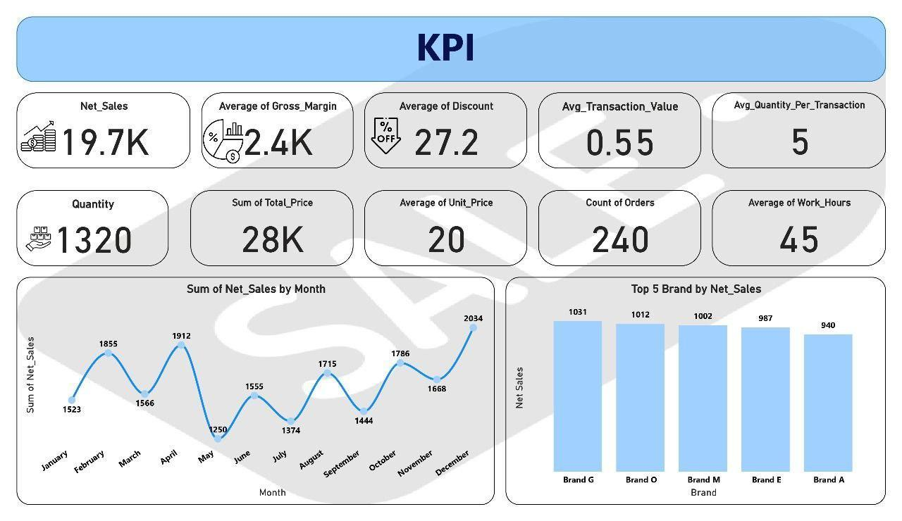

### **11. Data Analysis Using Python**

Python is used for advanced data analysis. A Jupyter notebook is created to analyze the dataset, extract key performance indicators (KPIs), and generate insights that are not directly visible in the Power BI reports. Python’s libraries, such as pandas, numpy, and matplotlib, are used for this purpose.

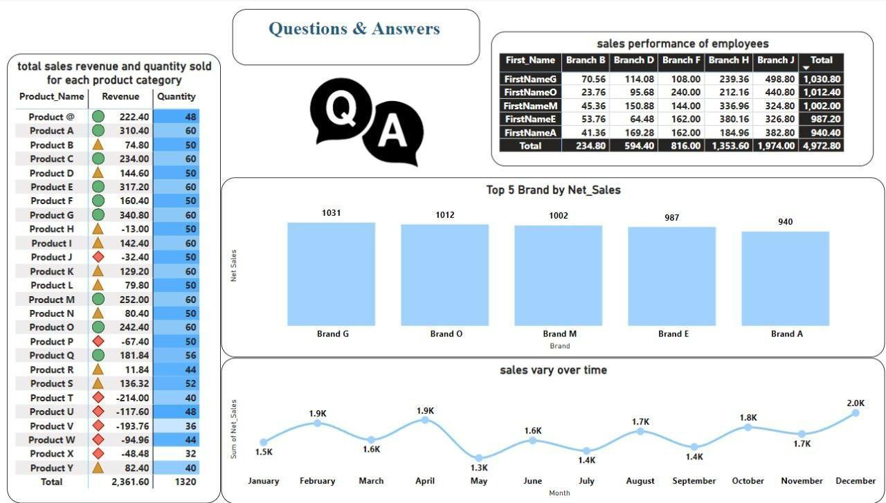

### **12. Machine Learning Model (Regression)**

Python is used for advanced data analysis. A Jupyter notebook is created to analyze the dataset, extract key performance indicators (KPIs), and generate insights that are not directly visible in the Power BI reports. Python’s libraries, such as pandas, numpy, and matplotlib, are used for this purpose.

Describe the machine learning model used to predict future supermarket profits. Discuss the features, algorithm, and model performance.

#### **Example:**

* **Regression Model**: Predicts total profit based on sales data, customer demographics, and promotions.
* **Model Performance**: Evaluate the model using metrics like R-squared or Mean Absolute Error (MAE).

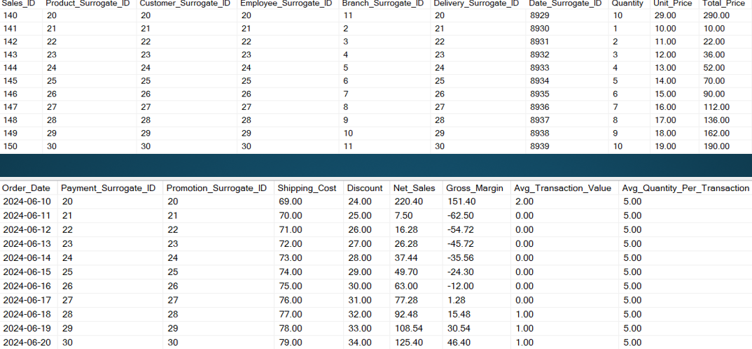

Data in FACT

### **13. Cloud Implementation (Microsoft Azure)**

---

Introduction

The Supermarket Management System Database project focuses on leveraging Azure to create an efficient and scalable data management system that supports various supermarket operations. This system is designed to manage key data such as inventory levels, sales transactions, and customer relationships, allowing for optimized decision-making through data-driven insights. The use of advanced analytics and reporting tools further supports business strategies by providing accurate, real-time information.

By migrating to Azure, this project ensures a robust, cloud-based infrastructure capable of handling large volumes of data with high performance. Services like Azure SQL Database provide the foundation for storing and managing data, while processes such as CSV data extraction enable flexibility in handling and analyzing data outside of the cloud environment.

---

Project Goals

3. Migrate Database to Azure SQL: Successfully transfer the existing schema and data from the local environment to Azure SQL Database, ensuring compatibility with Azure's cloud architecture. The database must meet the supermarket's growing demands for scalability, availability, and security. By migrating to Azure, the database benefits from cloud-native capabilities like automated backups, high availability, and integration with other Azure services.

4. Gather Business Information: Collaborate with stakeholders to identify and understand key business questions and objectives. This stage focuses on translating these business needs into actionable data requirements that will shape the data models, reports, and analytics developed throughout the project. Examples include tracking sales trends, optimizing inventory restocking, and analyzing customer purchasing behavior.

5. Data Model Optimization: Develop and optimize a data model tailored for cloud performance on Azure SQL Database. This involves ensuring that the database structure supports high efficiency in querying and data retrieval, leveraging partitioning, indexing, and other optimization techniques to ensure the system can handle large-scale queries and deliver real-time results in a cloud environment.

6. Data Warehouse on Azure: Design and implement a comprehensive data warehouse hosted on Azure, which serves as the central repository for all supermarket data. This warehouse enables cross-functional reporting and analysis, combining data from various operational systems such as inventory, sales, and customer management, ensuring data consistency and integrity.

7. ETL with SSIS & Azure: Use SQL Server Integration Services (SSIS) in conjunction with Azure to design and implement efficient ETL (Extract, Transform, Load) processes. These processes are responsible for importing data into the data warehouse from different sources, including real-time data from the Azure database. This ensures that the data warehouse remains up-to-date with the latest transactional data and is ready for analysis and reporting.

8. Extract Data to CSV: Extract data from the Azure SQL Database into CSV files for additional analysis, sharing, and backups. This allows flexibility, as the data can be used in various external tools for further manipulation and insights. CSV extraction also helps in archiving historical data, providing easy access to past records while ensuring that the operational database remains lean and efficient.

### **Detailed Steps for Cloud Implementation with Microsoft Azure**

Here’s a more detailed breakdown of the steps required to implement **Microsoft Azure** for the **Supermarket Management System Database Project**, focusing on creating **Azure Synapse Analytics**, **SQL pools**, and **Azure Blob Storage**.

### **1. Setting Up Azure Synapse Analytics Workspace**

**Azure Synapse Analytics** is a key component for managing big data and data warehousing needs. The workspace provides an integrated environment for ingesting, preparing, managing, and serving data for immediate business intelligence and machine learning.

1. **Log into the Azure Portal**:
   * Visit [Azure Portal](https://portal.azure.com) and log in with your Azure account credentials.
2. **Create an Azure Synapse Workspace**:
   * In the Azure portal, click on **"Create a resource"** and search for **Azure Synapse Analytics**.
   * Click on **"Azure Synapse Analytics"** and select **"Create"**.
3. **Configure the Workspace**:
   * **Subscription**: Select the subscription you want to use.
   * **Resource Group**: Either select an existing resource group or create a new one. Resource groups are containers that hold related resources.
   * **Workspace Name**: Provide a unique name for your Synapse workspace (e.g., SupermarketSynapseWorkspace).
   * **Region**: Choose a region close to your business location for optimal performance.
   * **Data Lake Storage Gen2 Account**: If you don’t have one, create a new **Azure Data Lake Storage Gen2** account. This will be used for managing large amounts of unstructured data.
   * **File System**: Enter a name for your workspace’s file system.
4. **Networking Settings** (optional):
   * Configure networking options like allowing public or private endpoint connectivity. For enhanced security, private endpoints are recommended to restrict access.
5. **Review + Create**:
   * Once you’ve filled in the necessary details, review your configuration and click **"Create"**. Azure will deploy your Synapse workspace, which could take a few minutes.

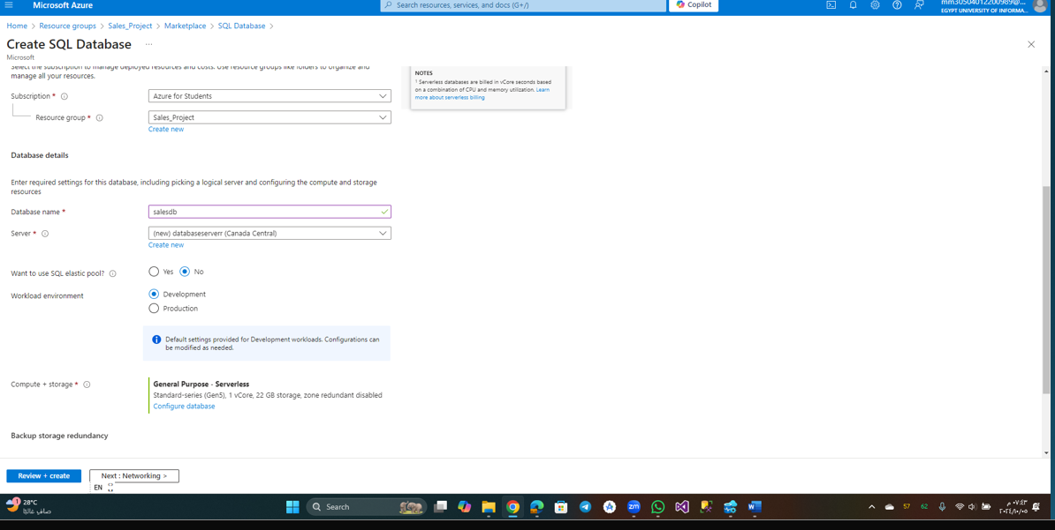

### **2. Setting Up SQL Pools in Azure Synapse Analytics**

**SQL pools** (formerly known as SQL Data Warehouses) are used for storing structured data and performing large-scale analytics. These pools can handle massive volumes of data, allowing the supermarket’s data warehouse to grow seamlessly as data accumulates.

1. **Access the Synapse Workspace**:
   * After your Synapse workspace is created, go to the **Azure Portal** and open your workspace from the resource list.
2. **Create a Dedicated SQL Pool**:
   * In the Synapse workspace overview, locate the **SQL Pools** section.
   * Click on **"New SQL Pool"**.
   * **SQL Pool Name**: Give a meaningful name to the pool.
   * **Performance Level**: Choose the desired performance level **Collation**: Set the collation based on your region and language preferences.
   * **Backup and Restore Settings**: Azure automatically backs up your SQL pool to ensure data protection, but you can adjust the backup frequency and retention policies based on your requirements.
3. **Deploy the SQL Pool**:
   * After configuration, click **"Review + Create"** to deploy your SQL pool. Once created, the pool is available for querying and analysis within your Synapse workspace.

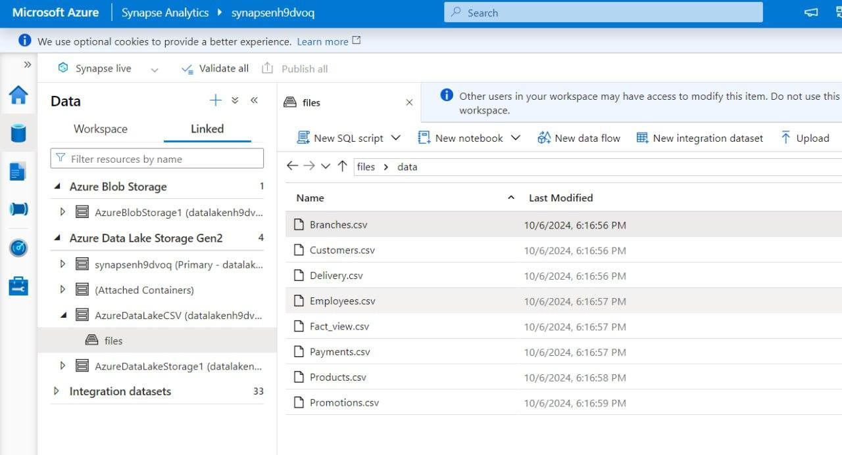

### **3. Data Ingestion into Azure Synapse Analytics**

To populate your **SQL pools** with data, use **Azure Data Factory** or **Synapse Pipelines** to automate the process of pulling data from multiple sources such as on-premises databases, cloud storage, or other external systems.

1. **Open Synapse Studio**:
   * Navigate to the **Synapse Studio** from the Synapse workspace overview page.
2. **Set Up Ingest Pipelines**:
   * In Synapse Studio, go to **Integrate** > **New Pipeline**.
   * Create a pipeline that automates the process of ingesting data from external sources (e.g., on-premises SQL databases, CSV files stored in Azure Blob Storage).
3. **Create Linked Services**:
   * Set up **Linked Services** to connect to your data sources (e.g., Azure Blob Storage, on-premises databases).
   * Each data source will have its own linked service. For instance, if you’re pulling data from an on-premises **POS system**, set up a **Linked Service** using **Azure Data Gateway** to securely connect to that system.

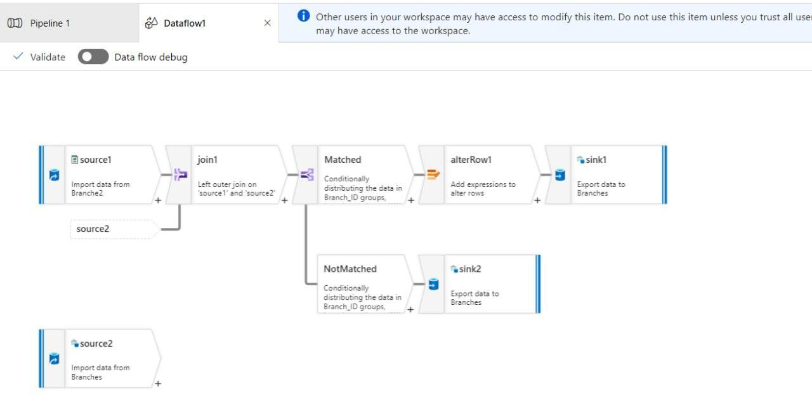

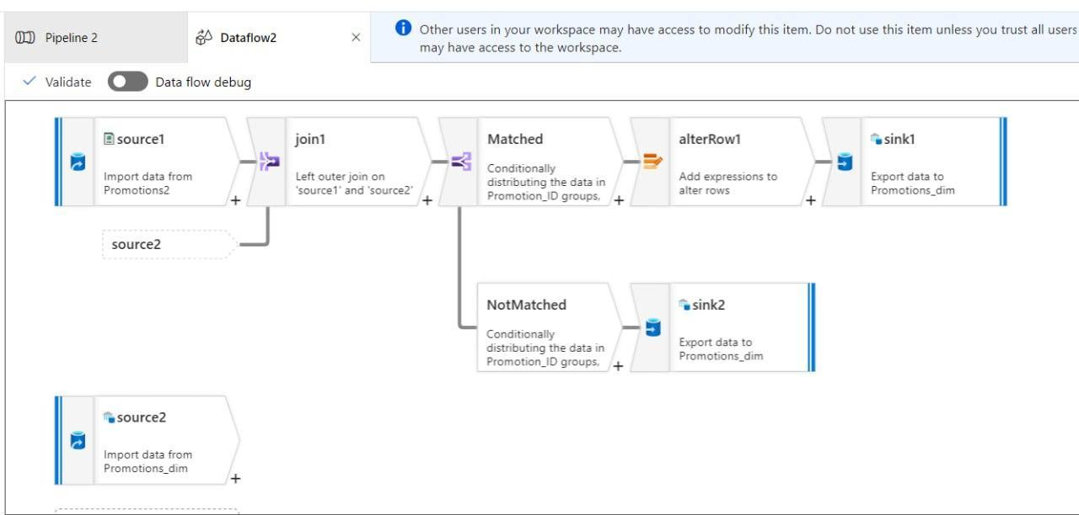

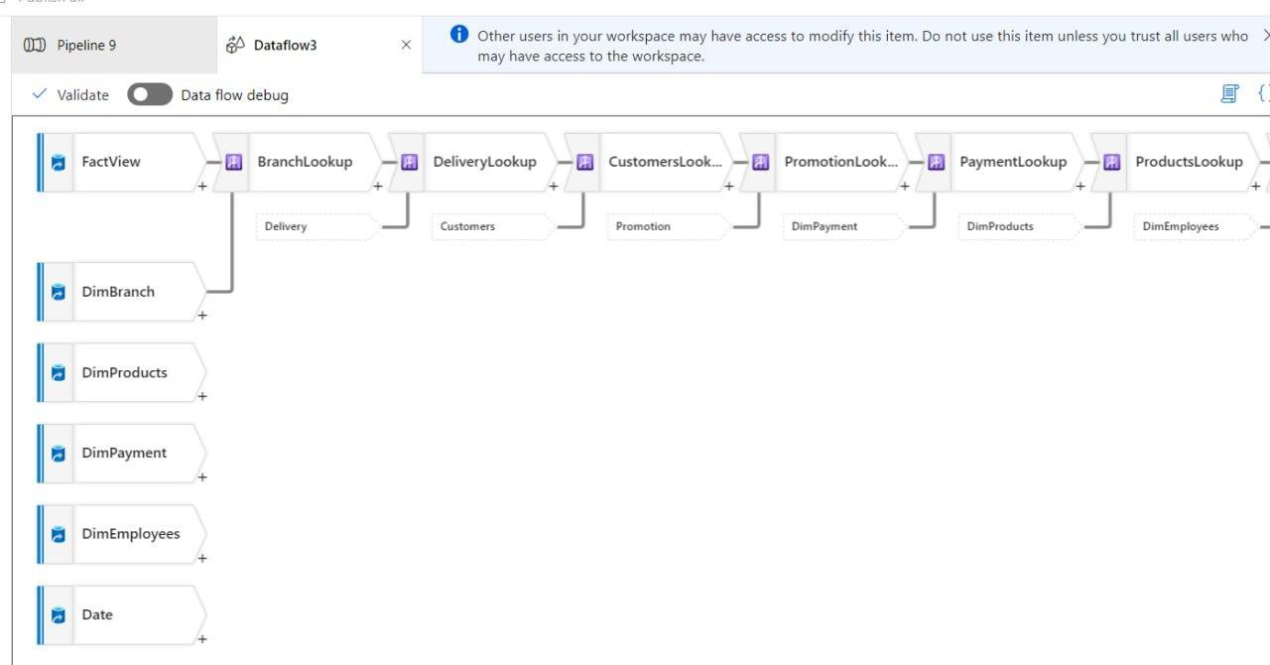

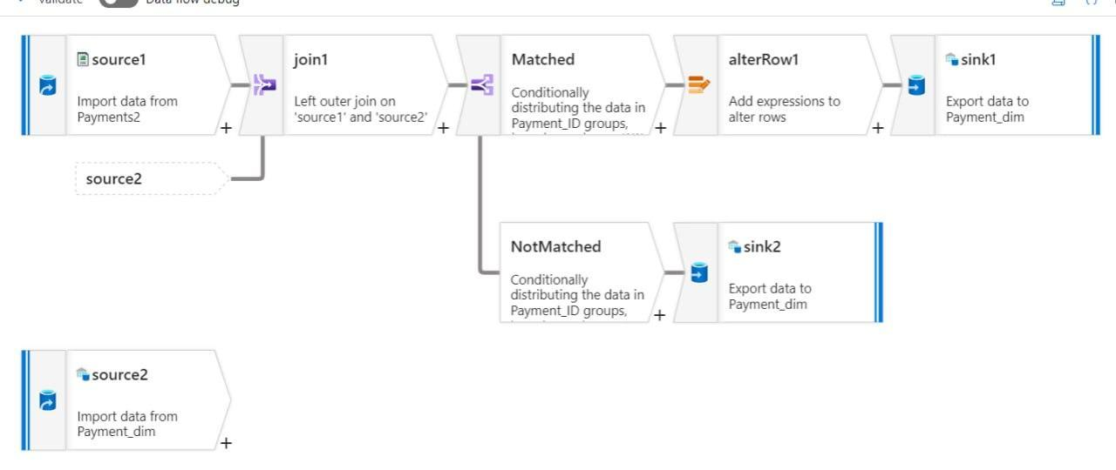

1. **Build Data Flows**:
   * Use **Copy Data** activities within your pipeline to move data from the source to the target SQL pools.
   * Map the source data fields to the corresponding columns in your fact and dimension tables within the SQL pool.

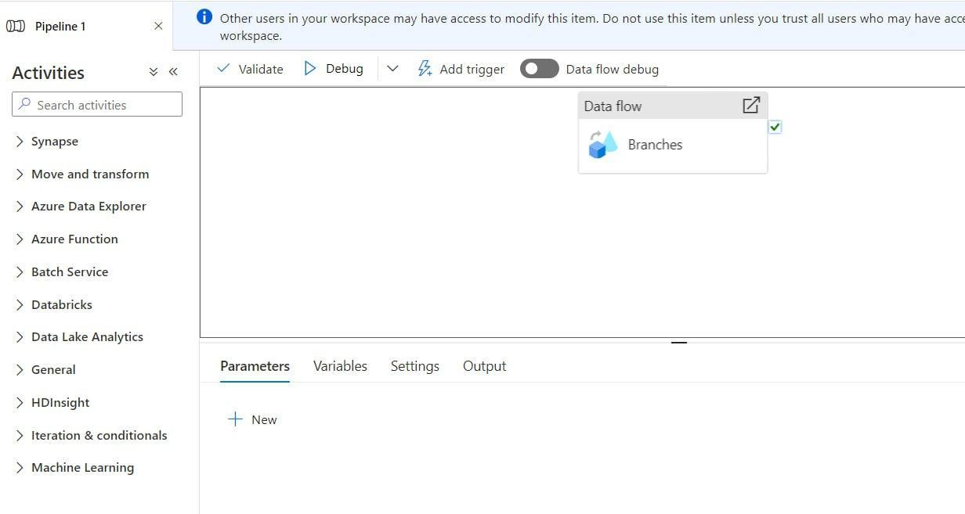

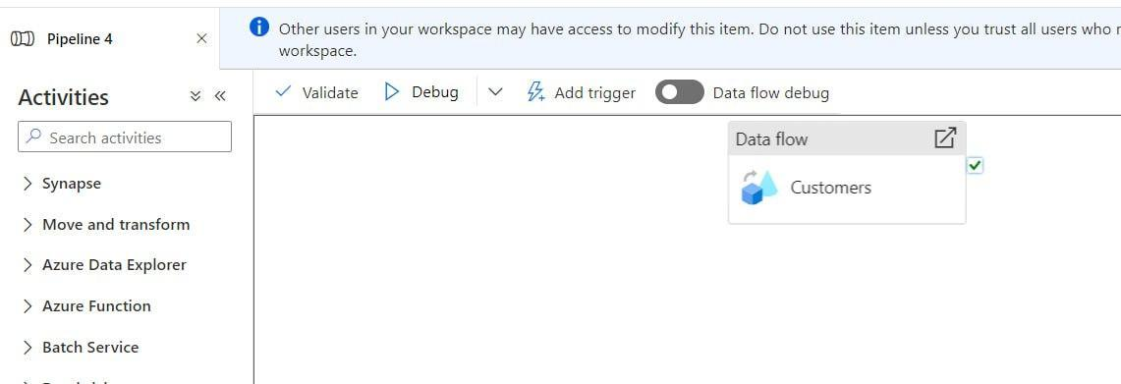

1. **Run and Schedule Pipelines**:
   * Test the pipeline by running it manually to ensure data is ingested properly.
   * Set up a schedule (e.g., daily, weekly) to ensure that data is updated regularly without manual intervention.

### **4. Setting Up Azure Blob Storage for Unstructured Data**

**Azure Blob Storage** is used for storing unstructured data like logs, backups, and files. It’s a cost-effective solution for storing large volumes of data that might not need to be processed immediately.

1. **Create a Storage Account**:
   * In the **Azure Portal**, click on **"Create a resource"** and search for **Storage Account**.
   * Choose **Azure Blob Storage** and click **"Create"**.
2. **Configure Storage Account Settings**:
   * **Storage Account Name**: Enter a unique name for your storage account
   * **Performance**: Choose between **Standard** (cheaper, general-purpose) and **Premium** (for low-latency, high-performance applications).
   * **Replication**: Select the appropriate replication option, such as **Locally Redundant Storage (LRS)** for cost-efficiency or **Geo-Redundant Storage (GRS)** for higher availability across regions.
   * **Access Tier**: Set the access tier based on how frequently you plan to access the data. For instance, **Cool** or **Archive** tiers are best for data that is rarely accessed, while **Hot** is suitable for frequently accessed data.
3. **Create a Container**:
   * Within your storage account, create a **Container** to store your files.
   * Set permissions for the container to control access.
4. **Upload Data**:
   * Use the **Azure Portal**, **Azure Storage Explorer**, or programmatic options (like Python, .NET SDKs) to upload files into the Blob Storage container.



### **5. Connecting Synapse to Blob Storage**

To access and analyze unstructured data stored in Blob Storage, you can connect Azure Synapse Analytics to your Blob Storage account.

1. **Set Up Linked Service**:
   * In **Synapse Studio**, go to **Manage** > **Linked Services**.
   * Add a new linked service for **Azure Blob Storage** and connect it to your Blob Storage account.
2. **Query Blob Storage Data**:
   * Use **Synapse SQL on-demand** to run SQL queries directly against data in Blob Storage, without needing to first load it into a SQL pool.

### **6. Finalizing Cloud Integration**

After setting up Azure Synapse Analytics and Blob Storage, your supermarket's data is now centrally stored and ready for analysis. **Power BI** or **other analytics tools** can now be used to connect to this cloud-based data warehouse for real-time reporting and insights.

### **Benefits of Azure Cloud Implementation**

1. **Scalability**: Resources (SQL pools, Blob Storage) can be easily scaled up or down based on the supermarket’s needs.
2. **Cost Efficiency**: Pay-as-you-go pricing allows the supermarket to only pay for what is used, avoiding the cost of maintaining physical servers.
3. **Security**: Azure provides robust data encryption, secure access policies, and compliance with industry standards.
4. **Flexibility**: Azure’s integrated platform allows for handling both structured (via SQL pools) and unstructured data (via Blob Storage), supporting comprehensive analytics and reporting.

By leveraging **Azure Synapse Analytics** and **Blob Storage**, the supermarket gains a cloud-based solution that supports efficient data management, flexible scaling, and cost-effective operations.

**14. Analysis And Machine Learning**

**1. Introduction**

This section outlines the analysis and machine learning processes applied to the data collected and stored in the data warehouse. The objective is to derive insights from the data and implement machine learning models to enhance decision-making.

**2. Data Preprocessing**

Before applying machine learning models, the data undergoes several preprocessing steps. Missing values are imputed using a mean-based approach, and categorical variables are encoded using one-hot encoding. Additionally, the data is normalized to ensure uniformity in scale.

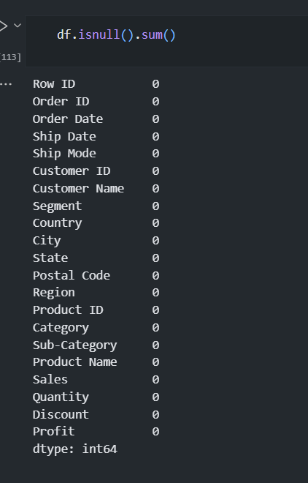

**3. Exploratory Data Analysis (EDA)**

The exploratory data analysis revealed key insights such as seasonal trends and a strong correlation between X and Y variables. Visualizations like histograms and scatter plots were employed to better understand the relationships between different features.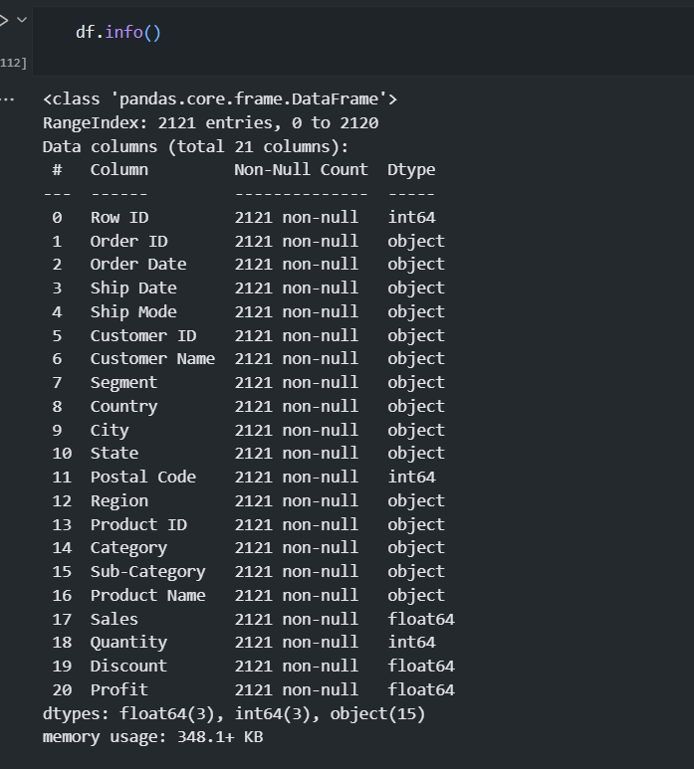

**4. Machine Learning Model**

For this project, a decision tree classifier was used to predict customer churn. The model was trained on a balanced dataset using stratified sampling, and cross-validation was implemented to evaluate performance. Feature importance metrics were also examined to understand the key drivers behind predictions.

**5. Model Evaluation**

The decision tree model achieved an accuracy of 72% with a precision of 0.82 . The model's performance was benchmarked against other algorithms such as logistic regression and random forests, with decision trees performing best in terms of both accuracy and interpretability.

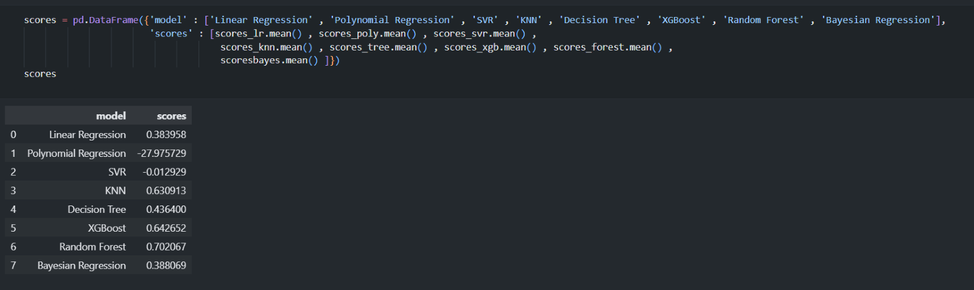

**6. Conclusion and Future Work**

The machine learning models have provided valuable insights into customer behavior, highlighting key factors contributing to churn. Future work could involve testing more advanced algorithms, such as neural networks, and expanding the dataset to include real-time streaming data.

### **15. Project Timeline**

Break down the project’s timeline, highlighting the key tasks and milestones.

* **Week 1**: ERD design and schema review.
* **Week 2**: Database creation and initial data load.
* **Week 3**: ETL development and reporting setup.
* **Week 4**: Final testing, adjustments, and project review.

### **16. Conclusion**

The Supermarket Management System Database project is a comprehensive initiative aimed at enhancing the operational efficiency and decision-making capabilities of the supermarket. Through meticulous design, robust implementation, and advanced reporting, this project will deliver a powerful tool for managing and analyzing supermarket data. The completion of this project will streamline daily operations and provide valuable insights that will drive business growth.